2019 Schwab Market Outlook



Schwab Center for Financial Research™

Schwab’s team of market experts share their perspectives and provide investment guidance

EXECUTIVE SUMMARY

Be Prepared

## Last year, our Market Outlook theme was “it’s getting late,” which accurately forecast what happened in 2018: an expansion of the late-stage business cycle and an increasingly bumpy ride for stock markets. We’ve already seen declining growth rates in 2018, and heading into 2019 there are signs that an economic peak and potential recession may be coming. Rising interest rates, declining liquidity, and sluggish global growth—with trade conflicts as an additional headwind—may weigh on economic growth and market performance in 2019.

Investors should be prepared for increasing market volatility, and possibly even a bear market, in the coming year.

Each section in this 2019 Schwab Market Outlook—U.S. Stocks & Economy, Global Stocks & Economy, and Fixed Income—will discuss ways to prepare for potentially changing conditions. Having a financial plan and an appropriately diversified portfolio are two key first steps for weathering any market environment. Note that this is just a one-year outlook, and investors should keep their investing time horizon in mind before reacting to any forecasts.

Key points:

* We expect U.S. economic growth to slow in 2019, with the risk of a recession rising.
* Earnings growth likely will slow, as year-over-year comparisons with strong 2018 earnings become more challenging.
* Trade tensions remain a risk, but inflation and interest rates are the key indicators to watch.
* The Federal Reserve likely will continue to raise short-term interest rates, but at a slower pace than in the past, and may pause or end rate hikes by mid-2019.
* Ten-year Treasury yields likely already have peaked at the 3.25% level.

Animal spirits sustainable?

* Corporate and consumer “animal spirits” may come under pressure from trade uncertainty, tightening financial conditions, slowing earnings growth as the impact of tax cuts fades, and financial market volatility.
* The tight labor market has put increased pressure on wage growth, which could compress corporate profit margins and lead to higher interest rates. Additional U.S. dollar strength and continued market volatility could further strain financial conditions.
* Economic data in “level” terms remain healthy, but 2019 will increasingly see “rate of change” deterioration. Remember my well- worn adage: “When it comes to the relationship between economic fundamentals and stock prices, better or worse matters more than good or bad.”

KEY POINTS

U.S. economic growth was strong in 2018, but some of the forces behind that strength were either short-term or likely to fade going forward. We expect U.S. economic growth to slow in 2019, with the risk of a recession rising. Trade friction, which remains an uncertainty heading into 2019, could be an important indicator of the length of runway between now and the next recession.

There has been a relatively unprecedented gap between consistently better-than-expected “soft” economic data (survey- and confidence- based) and worse-than-expected “hard” economic data (quantifiable metrics). Soft data have been supported by persistently strong business and consumer confidence, but a risk heading into 2019 is that animal spirits could fade.



# Liquidity tide is heading out

* Discipline around diversification and rebalancing will be important in 2019. Recession risk is rising, and stocks historically have posted their weakest performance during the six months leading up to recessions.
* Stocks’ historically strong post-midterm- election performance trend is a tailwind, but trade uncertainty and/or the political landscape could serve as offsetting headwinds.
* “Rolling” or “stealth” bear markets—in which certain stocks or market sectors fall into bear territory, even if the overall market isn’t—may continue in 2019 as sectors and asset classes continue to reprice for receding global liquidity.

TAKEAWAYS

Market volatility is a 2018 theme that is likely to persist in 2019. After a decade of unprecedented liquidity provision courtesy of the Federal Reserve, liquidity is draining out of the system as the Fed and other central banks move toward tighter monetary policy.

Earnings growth likely will decelerate sharply in 2019, as year-over-year comparisons become more challenging in light of the tax-cut-related boost to earnings in 2018. Continued U.S. dollar strength and the impact of trade tariffs could be additional headwinds for earnings, even though stock valuations have become more reasonable.

Investor sentiment is likely to swing in a wider range in 2019 assuming volatility persists, although the bouts of excessive optimism seen in 2018 likely will fade.

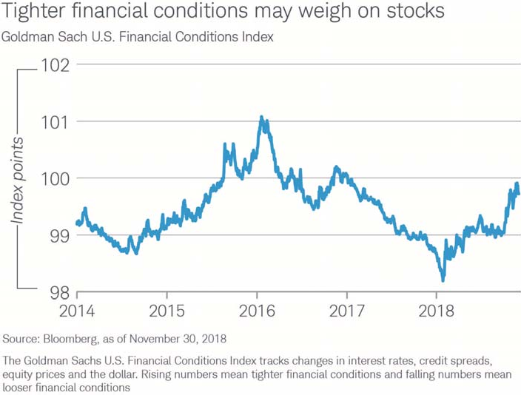

Graphic goes here

# Global slowdown

* Global growth is likely to slow as the economic cycle nears a peak.
* Trade tensions, inflation and interest rates are key indicators to watch as financial conditions tighten and act as a drag on markets and the economy.
* Watch the gap between unemployment and inflation rates, along with the yield curve, for signs of a peak in economic growth ahead of a potential recession.

KEY POINTS

Global growth may slow in 2019 as the economic cycle nears a peak, with increasing drag from worsening financial conditions combining with full employment and rising prices. Global stock markets may peak in 2019 if leading indicators signal the gathering clouds of a global recession.

If we borrow the severe weather scale for storms and apply it to the global economy and markets, we aren’t forecasting “Recession Warning,” meaning a recession is here or imminent. A better term is “Recession Watch,” in which conditions are favorable to a recession if a number of risk factors (e.g., trade, interest rates, inflation) deteriorate.

While trade tensions have the potential to inflict substantial damage on the world economy, it would require a significant escalation from the measures implemented so far to trigger the next global recession.

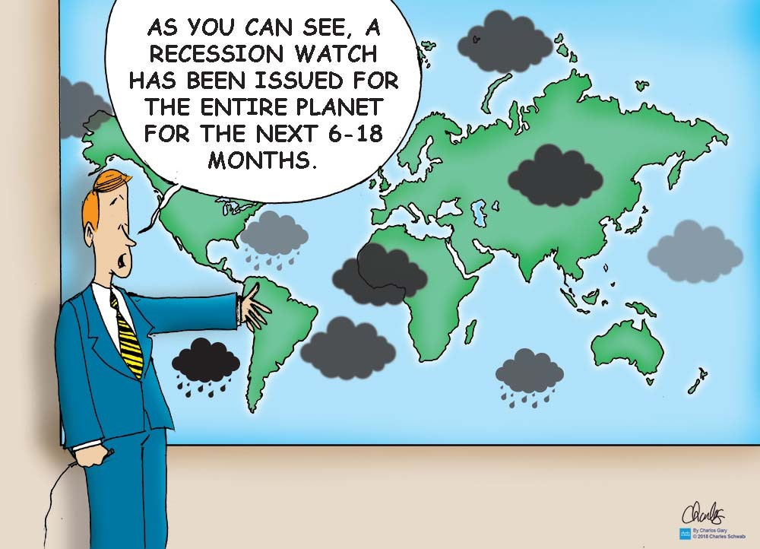

# Indicators may point to stock market peak

* International stocks may continue to see heightened volatility and could enter a bear market if key indicators continue on their current path.
* Consider reducing portfolio volatility by trimming historically more-volatile asset classes, such as emerging market stocks.
* Consider rebalancing back to long-term asset allocation targets. Historically, long-term asset class trends have tended to reverse in the year prior to global recessions and bear markets. This may begin to favor international over U.S., value over growth, and large- over small-cap stocks.

TAKEAWAYS

For all the concerns about trade policy, Brexit and other issues, 2018's big stock market declines generally were driven by inflation and interest rate concerns. These are the indicators investors should watch most closely in 2019.

Historically, when unemployment and inflation rates have converged to become the same number—signaling an overheating economy—it has marked the beginning of a prolonged downturn for the stock market, followed about a year later by a recession. The gap between the unemployment rate and the inflation rate is close to one percentage point in major countries like Germany, Japan, the United Kingdom, and the United States. Another leading indicator, the yield curve, also has shown a narrowing gap between short- and longer-term Treasury yields. These gaps may close in 2019 and signal a peak for international stocks ahead of a global recession.

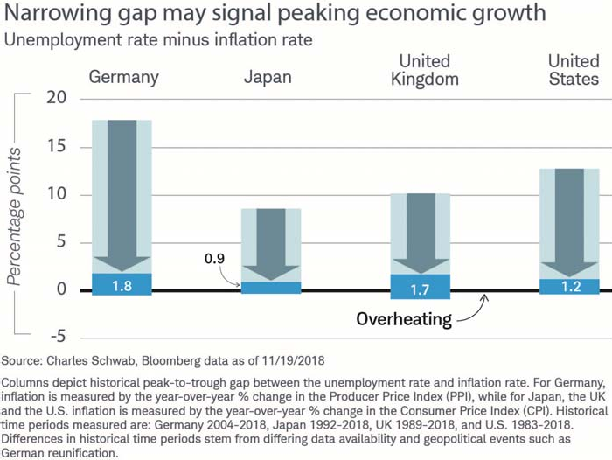

# Peak expectations

* Ten-year Treasury yields may have peaked for this cycle at 3.25%. Tighter central bank monetary policy, a strong dollar and weaker global growth may dampen growth and inflation prospects in 2019, limiting the rise in bond yields.
* The Fed may pause or end federal funds rate hikes by mid-2019, near 3%, if the yield curve flattens and inflation remains tame.
* Volatility likely will continue as markets adjust to the end of the easy-money era.
* We expect the dollar to stay firm until there is evidence that the Fed is done tightening and/or global growth picks up.

KEY POINTS

The worst may be over for the bond bear market. After more than two years of steadily rising bond yields (and falling bond prices, which move inversely to yields), our research suggests that 10-year Treasury bond yields may have peaked for this tightening cycle at the 3.25% level. The Federal Reserve likely will continue to raise short-term interest rates to about 3% in 2019, but we don’t see longer-term yields moving much above the recent highs. Tighter global monetary policy, a strong U.S. dollar and sluggish global growth exacerbated by trade conflicts are likely to weigh on economic growth and inflation, limiting the rise in bond yields.

However, the path forward isn’t likely to be smooth. As markets adjust to tightening financial conditions, volatility is likely to increase.

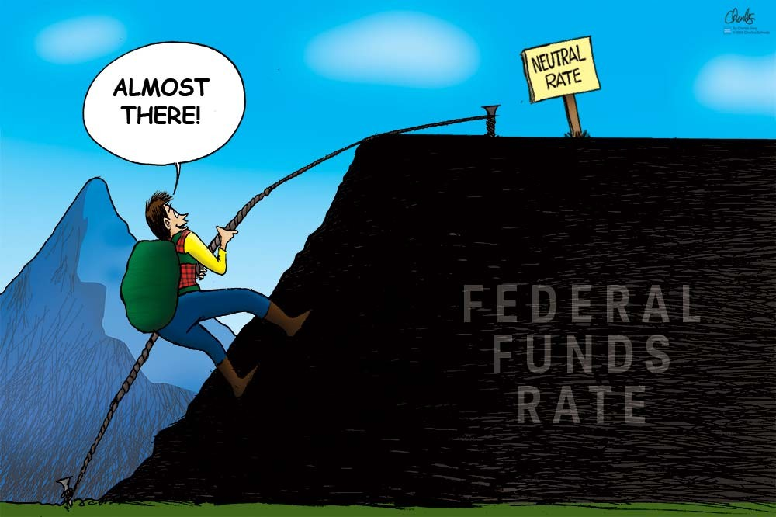

# It’s stormy at the top

* Consider adding to portfolio duration as bond yields rise, in order to capture more income, as the business cycle advances.
* Consider moving up in corporate credit quality. Corporate bond market risks are rising, but the additional “yield premium” that both investment-grade and high-yield corporate bonds offer versus Treasuries remains relatively low.
* Consider higher-rated municipal bonds, in the five- to eight-year part of the yield curve. Although muni credit quality is generally strong (albeit with pockets of risk), tight credit spreads don’t justify taking on additional credit risk.

TAKEAWAYS

We expect the Federal Reserve to raise rates two to three more times, bringing the federal funds target rate to the 2.75% to 3% area in early 2019, short of the Federal Open Market Committee’s 3.4% median estimate for 2020.¹ Because short- and long-term interest rates tend to converge at cycle peaks, the yield curve likely will flatten toward zero.

We suggest investors gradually add to average portfolio duration when yields rise.

As the Fed normalizes rates and reduces its balance sheet, volatility may increase in riskier parts of the fixed income market—such as bank loans, high-yield and emerging-market bonds—due to issuers’ high leverage.

We suggest investors move up in credit quality and/or limit exposure to these asset classes. Municipal bonds may post solid performance in 2019, as demand appears strong for tax-exempt income.

¹Based on the FOMC Summary of Economic Projections, 09/26/2018

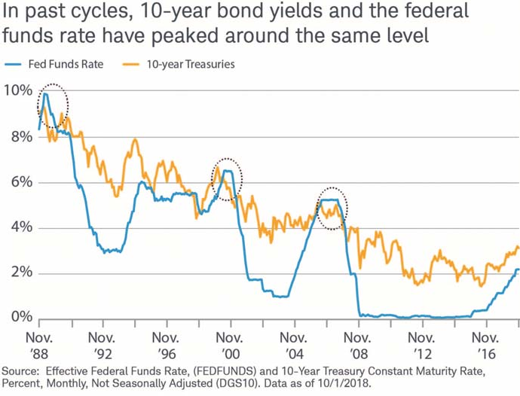



OUR TEAM

Schwab’s Market Experts

**Important Disclosures:**

**Past performance is no guarantee of future results.** Forecasts contained herein are for illustrative purposes, may be based upon proprietary research and are developed through analysis of historical public data.

The information here is for general informational purposes only and should not be considered an individualized recommendation or personalized investment advice. The type of securities and investment strategies mentioned may not be suitable for everyone. Each investor needs to review a security transaction for his or her own particular situation.

Investing involves risk including loss of principal.

Data here are obtained from what are considered reliable sources; however, their accuracy, completeness, or reliability cannot be guaranteed. Supporting documentation for any claims or statistical information is available upon request.

All expressions of opinion are subject to change without notice in reaction to shifting market, economic or geopolitical conditions.

Indices are unmanaged; do not incur management fees, costs, or expenses; and cannot be invested in directly.

Fixed income securities are subject to

increased loss of principal during periods of rising interest rates. Fixed-income investments are subject to various other risks including changes in credit quality, market valuations, liquidity, prepayments, early redemption, corporate events, tax ramifications and other factors.

International investments involve additional risks, which include differences in financial accounting standards, currency fluctuations, geopolitical risk, foreign taxes and regulations, and the potential for illiquid markets. Investing in emerging markets may accentuate these risks.

Tax-exempt bonds are not necessarily a suitable investment for all persons.

Information related to a security’s tax- exempt status (federal and in-state) is obtained from third-parties and Schwab does not guarantee its accuracy. Tax- exempt income may be subject to the Alternative Minimum Tax (AMT). Capital appreciation from bond funds and discounted bonds may be subject to state or local taxes. Capital gains are not exempt from federal income tax.

High-yield bonds and lower-rated securities are subject to greater credit risk, default risk, and liquidity risk.

Diversification and rebalancing strategies do not ensure a profit and do not protect against losses in declining markets.

Rebalancing may cause investors to incur

transaction costs and, when rebalancing a non-retirement account, taxable events may be created that may affect your tax liability.

The Schwab Center for Financial Research is a division of Charles Schwab & Co., Inc.

**Index and Term Definitions**

The Goldman Sachs U.S. Financial Conditions Index tracks changes in interest rates, credit spreads, equity prices and the dollar. An increase indicates tightening of financial conditions and a decrease indicates easing.

The Producer Price Index (PPI) is a family of indexes that measures the average change over time in selling prices received by domestic producers of goods and services. PPIs measure price change from the perspective of the seller.

The Consumer Price Index (CPI) is a measure that examines the weighted average of prices of a basket of consumer goods and services, such as transportation, food and medical care. It is calculated by taking price changes for each item in the predetermined basket of goods and averaging them.

©2018 Charles Schwab & Co., Inc. All rights reserved. Member SIPC.

(1218-8RZ0)